This lesson looks at the responsibilities humans have towards animals by focusing on RSPCA inspectors.

Starter activity
Focus on RSPCA inspectors
- Talk to the pupils about some of the staff we have working at the RSPCA.
- As of 2016, we have approximately 267 full time (46 part time) RSPCA inspectors, 18 trainee inspectors, 55 full time (3 part time) animal welfare officers (AWOs) and 77 full time (6 part time) animal collection officers (ACOs) working to prevent cruelty and promote kindness to animals in England and Wales.
- Explain that the RSPCA Inspector is a paid role, and not a voluntary one, that involves being a mixture of a police officer, animal welfare adviser, fundraiser and PR person. Animal Welfare Officers deal mainly with animal collections and low-level complaints. Can pupils come up with suggestions for what they think RSPCA inspectors do? Show them the photo of an inspector and the factsheet What do RSPCA inspectors do?
- Point out that the inspector's main job is to prevent cruelty to animals, not to prosecute as many offenders as possible. They are asked for advice, respond to phone calls, investigate animal problems, deal with complaints of animal cruelty and emergencies.
- Tell the pupils that when inspectors are called out, they never know what they are going to find. They have to think on their feet and decide quickly what to do.
Learning styles: auditory.

Main activity
What would you do?
Using the worksheet Pet welfare cards and a selection of soft toys to represent the animals, set up these scenarios in the classroom. Alternatively, pupils can simply read the cards. Working in groups, look at each situation and let the pupils decide what they would do if they were an inspector. Remind them that the inspector has to decide what is right for the animal. Discuss the pupils' ideas. If there is time, they could act out the stories. See the teachers' notes What the inspector might do to find out what an inspector might do in the situations relating to the cards.
Taking action
- As a class, look at one of the scenarios. If you have completed the session We all have basic needs, refer to pupils' lists of what animals need to be healthy and happy. Or you can use The five welfare needs factsheet to consider which of these apply to the animal(s) in the scenario. Use the worksheet RSPCA inspector's notes to complete a record for this animal. In small groups, work through the other scenarios using this model.
- Ask one representative from each group to read their notes, for each scenario, to the class. Have any groups come up with the same solutions? Which do they think are the best actions to take?
Learning styles: visual, auditory, kinaesthetic

Plenary activity
What if...?
Ask pupils what they have learned about RSPCA inspectors. Remind them of the scenarios and ask them to consider the question 'What would happen to these animals if the RSPCA didn't exist?'.
Learning styles: auditory.

Differentiation
- For a simpler main activity, children can decide whether the animal would be healthy and happy in each scenario and write a sentence to explain why. Alternatively, they could just answer the five questions in the RSPCA inspector's notes .
- Some pupils could write a script for one of the scenarios, which involves the inspector interviewing the owner and invite feedback from the class. What would they do differently?

Display
Pupils could write their ideas on sticky notes and put them next to each of the scenarios.

Did you know?
- In 2007 the law relating to the welfare of pets in England and Wales changed. Under the Animal Welfare Act anyone who is responsible for a pet now has a legal responsibility to meet the five basic welfare needs These are:
  - A suitable place to live - Animals should have the right type of home, including shelter, enough space, and somewhere comfortable to rest and hide.
  - A healthy diet - Animals should have access to fresh, clean water all the time and should be given the right type and amount of food to keep them fit and healthy.
  - The ability to behave normally - Animals should have enough space and the right kind of facilities to allow them to behave normally.
  - The company he or she needs - Animals should be given appropriate company. Some animals should have company and some should be kept on their own.
  - To stay healthy - Animals should be protected from pain, suffering, injury and disease and should be treated by a vet if they are sick or injured.
- The Animal Welfare Act provides much greater protection for animals. Under the old law, people responsible for pets could only be prosecuted for cruelty once suffering had occurred, and when it was often too late to save the animal from death or lasting injury.
- A person commits the welfare offence if he/she does not take reasonable steps to ensure that the needs of an animal for which he/she is responsible are met.
- There are two separate offences relating to unnecessary suffering:
- to cause unnecessary suffering to an animal by an act or failure to act
- to permit unnecessary suffering to an animal for which that person is responsible, which has been caused by another person.
- If a person is found guilty of offences under the Act, they may be subject to:
- custodial sentences of up to six months
- deprivation orders (taking the animal away)
- disqualification orders (banning a person from owning, keeping, controlling, influencing, dealing or transporting animals)
- fines of up to £20,000
- destruction of the animal.
- Most of the cases seen by RSPCA inspectors are neglect caused by people who do not know how to look after animals properly. People don't understand how much time, effort and money are needed to care for their pets properly. Sadly, some people are also deliberately cruel to animals.
- Every 25 seconds, someone somewhere in England and Wales dials 0300 1234 999 - the RSPCA's national cruelty and advice line - for help.
- There were 153,770 complaints of cruelty investigated by our inspectors in 2013 which resulted in 3,961 convictions.

Curriculum objectives
Pupils should learn:
- about the responsibilities humans have towards animals
- about voluntary charitable organisations and why we need them
- about the history and role of a local and/or national animal welfare organisation.

Learning outcomes
At the end of this lesson:
- most pupils: understand the role of voluntary organisations/charities. They recognise that different pets have different needs and that not everyone makes a suitable pet owner
- some pupils have not made so much progress and: understand the role of voluntary organisations/charities
- some pupils have progressed further and: understand the role of voluntary organisations/charities and why we need them. They recognise that different pets have different needs, and that not everyone makes a suitable pet owner. They contribute ideas and opinions to class discussions.

Useful websites
RSPCA - All about animals - General pet care
RSPCA - About us
RSPCA - Animal Welfare Act
RSPCA - All about animals
RSPCA - Careers
RSPCA - Become an RSPCA officer

Factsheet – What do RSPCA inspectors do?

The spider diagram below shows the things an inspector can do. He or she won’t always do all of them. Their job is to decide the best action to take for the animal.

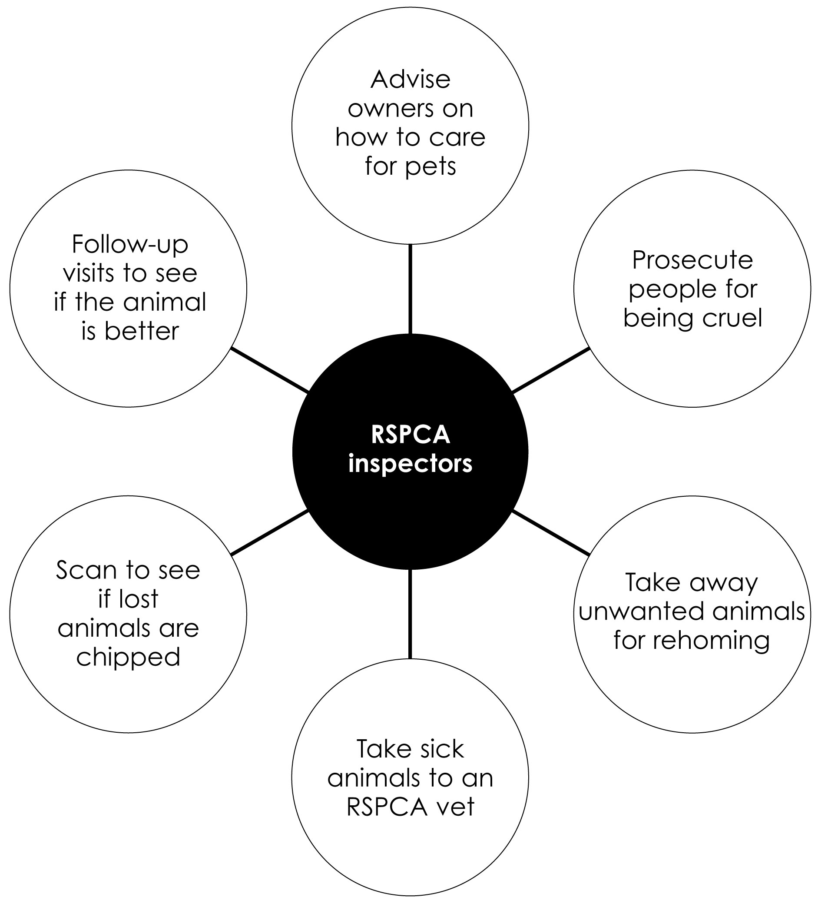

What action will you take to help your animal?
Worksheet – RSPCA inspectors notes

Inspector’s name: .……….………………………………………………….

Animal being inspected: …………………………………………………..

- Is it hungry or thirsty? Yes / No
- Is it uncomfortable? Yes / No
- Is it hurt? Yes / No
- Can it behave normally? Yes / No
- Is it scared or upset? Yes / No

Inspector’s action:
........................................................................................................................................................................................................................................................................................................................................................................................................................................................................................................................................................................................................................................................................................................................................................................................................................................................................................................................
Teachers’ notes – What the inspector might do

Group of cattle
An inspector would contact the farmer and get the cattle moved to higher ground.

Goldfish at a garden centre
An inspector would go in and ask to check the animals, liaise with the local authority, check whether the garden centre had a licence, advise the garden centre on how to keep the fish in better conditions and then do a follow-up visit.

Thin pony in field
The inspector would go and look at the pony, find the owner and advise the owner on good feed and shelter, then do a follow-up visit.

Abandoned cat
The inspector would try to see the cat, enquire if anyone is looking after it and if no one is, then would take it and make sure it is safe. This might be followed up by a prosecution.

Rabbit in small hutch
An inspector would look at the rabbit and advise the owner, check to see if the hutch, feed and water are adequate, if it has sufficient bedding and room to exercise. If the owners no longer want it, the RSPCA would find the rabbit a new home.

Abandoned puppy
The inspector would collect the puppy and try to find the owner, perhaps through the local press.

Worksheet – Pet welfare cards

Here are some problems an inspector might face.

What would you do?

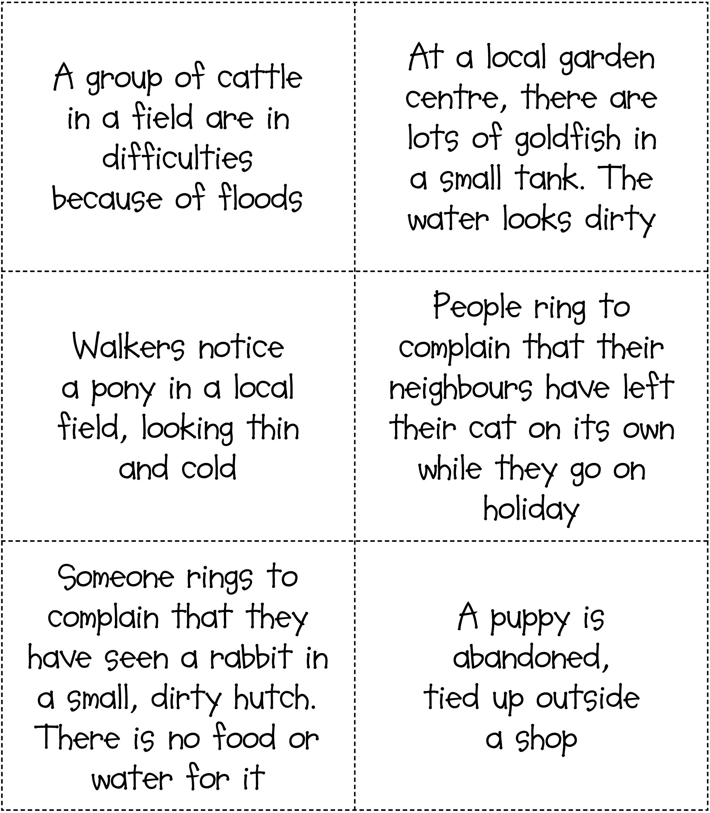

Factsheet – The five welfare needs
The Animal Welfare Act 2006 requires anyone who owns or looks after an animal to provide everything that the animal needs to be happy and healthy. These needs can be described as:


A suitable place to live
Animals should have the right type of home, including shelter, enough space, and somewhere comfortable to rest and hide.


A healthy diet
Animals should have access to fresh, clean water all the time and should be given the right type and amount of food to keep them fit and healthy.


The ability to behave normally
Animals should have enough space and the right kind of facilities to allow them to behave normally.


The company he or she needs
Animals should be given appropriate company. Some animals should have company and some should be kept on their own.


To stay healthy
Animals should be protected from pain, suffering, injury and disease and should be treated by a vet if they are sick or injured.

