This lesson looks at the complex needs of exotic (non-domestic) pets and the responsibility involved in looking after them.

Starter activity
What is an exotic pet?
- It is difficult to give a clear definition of 'exotic'. However, any animal that is not native to the country where it is kept in captivity can be called an exotic (non-domestic) animal. Generally, these animals are not adapted to the climate and wild environment in the country where they are kept. Therefore, they are often completely reliant on their keeper to provide the appropriate captive environment and food they need to stay healthy and to exhibit their natural behaviours.
- The following background information will be helpful with this lesson.
- All pets, including exotic animals, require proper care and attention. But exotics can be more expensive to feed and look after properly and they often require specialist living conditions.
- Some owners keep exotic animals in unsuitable conditions, which cause a variety of illnesses and injuries. It can also be difficult and costly to find a vet who is experienced in treating these animals.
- People often buy young animals without finding out how big they will grow and how long they will live. As a result, pet owners might abandon or neglect the animals when they reach their full size. The RSPCA has rescued more than 2,000 exotic animals each year, since 2000, who were abandoned or suffering unnecessarily.
- Keeping a pet can be a lifelong commitment. Therefore, it's important to do your homework before you buy any animal. Be sure that you can provide a suitable diet, care and captive environment for the rest of the animal's life.
- Working in groups or pairs, ask the class to mind map what an exotic (non-domestic) pet is.
- They can then feed back to the group the types of animals they think exotic pets may be. For example:
- spiders, such as tarantulas
- frogs, toads, salamanders and newts from tropical countries
- green iguanas, geckos and chameleons
- exotic snakes
- tortoises and terrapins
- parrots and other exotic birds
- monkeys
- chinchillas, chipmunks and gerbils.
- Why does the class think that people keep exotic pets?
Learning styles: visual, auditory.

Main activity
Focus on iguanas
- Show the pupils the photo of the iguana from the collection of images Pets.
- Tell them iguanas come from tropical places in the Caribbean and in Central and South America.
- Ask them to think about the conditions iguanas are used to in these places - heat, sun, monsoon conditions.
- How do the pupils think iguanas feel when they come to the UK? How are conditions different here?
- Show the pupils the factsheet Suitable pets? and ask them to read through it with you. Read it a second time and ask the pupils to make a note of all the different things you need to buy to look after a green iguana properly. Ask the class to feed back what they noted. Write a list of their suggestions, which might include:
Vivarium, thermostat, hygrometer (to measure humidity), special lights, heat sources, food
Water, plants and branches.
- In pairs, ask the pupils to compare a common pet, such as a dog, with an iguana. What are the differences? What do dogs need to be happy and healthy and what do iguanas need?
Learning styles: visual, auditory.

Plenary activity
Suitable pets
After feeding back these ideas to the class, ask groups of pupils to decide whether they think animals such as iguanas make good pets. Ask the class to share their experiences of exotic pets. Do they know someone who owns one? Do they have an exotic pet themselves?
Learning styles: auditory.

Extension activities
- Ask pupils to write to the chief environmental officer at their local authority and suggest ways that pet shops could promote responsible pet ownership. For example, pet shop staff should be trained in exotics' care so they can give customers detailed information when they buy exotic pets. The local authority could set strict licensing standards for pet shops and visit them regularly to ensure the guidelines are being followed.
- Work through the pets flipcharts on the Promethean Planet website.

Did you know?
- A wide variety of animals are now bred in captivity in the UK. But each year, millions of wild animals continue to be trapped around the world, including from South America and Africa, for use in the pet trade. Many die at the time of capture and before reaching the point of sale. With the combined impact of habitat destruction, this means that several species, including parrots and tortoises, are now endangered.
- In 2007 the law relating to the welfare of pets in England and Wales changed. Under the Animal Welfare Act anyone who is responsible for a pet now has a legal responsibility to meet the five basic welfare needs (the five freedoms). These are:
  - A suitable place to live - Animals should have the right type of home, including shelter, enough space, and somewhere comfortable to rest and hide.
  - A healthy diet - Animals should have access to fresh, clean water all the time and should be given the right type and amount of food to keep them fit and healthy.
  - The ability to behave normally - Animals should have enough space and the right kind of facilities to allow them to behave normally.
  - The company he or she needs - Animals should be given appropriate company. Some animals should have company and some should be kept on their own.
  - To stay healthy - Animals should be protected from pain, suffering, injury and disease and should be treated by a vet if they are sick or injured.

- How you can help
There are several ways you can contribute to preventing the trade of wild-caught animals and promoting best practice in pet shops, including:
- Only buy animals that have been born and reared in captivity in the UK
- Ask pet shops not to sell wild-caught animals
- Write to your local authority and ask them to set strict licensing standards for pet shops so staff are properly trained in exotics' care and can provide customers with detailed information on caring for exotic (non-domestic) pets.

Curriculum objectives
Pupils should learn:
- about the responsibilities humans have towards animals.
- that it is important to think carefully about whether a particular pet will suit your lifestyle.

Learning outcomes
At the end of this lesson:
- most pupils: know that we all have a responsibility towards animals. They recognise that different pets have different needs
- some pupils have not made so much progress and: know that we all have a responsibility towards animals
- some pupils have progressed further and: know that we all have a responsibility towards animals. They recognise that different pets have different needs, and that not everyone makes a suitable pet owner. They contribute ideas and opinions to class discussions.

Vocabulary
captivity exotic humidity hygrometer non-indigenous animals
thermostat vivarium

Useful websites
RSPCA - All about animals - Other pets
Defra - Animal Welfare Act
Pets flipcharts - Promethean Planet
Video - What do pets need?

Image – iguana

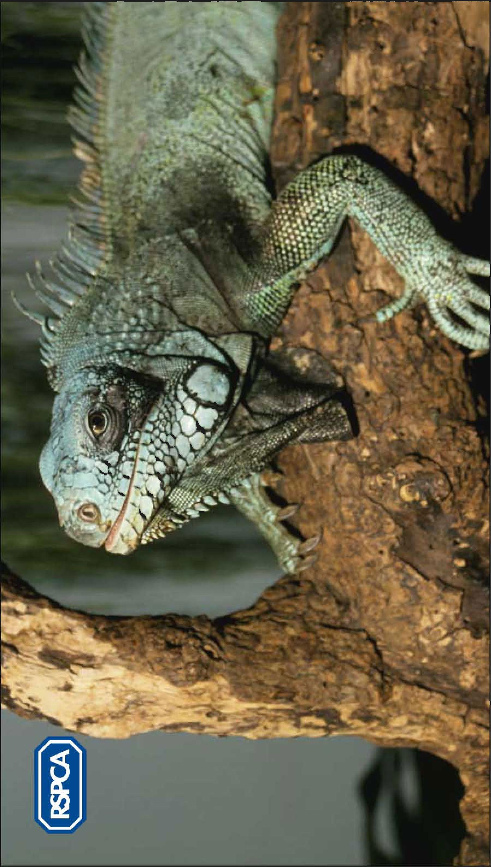
Factsheet – Suitable pets?

Green iguana

Where do they come from?
Green iguanas come from the Caribbean and Central and South America – over 3,000 miles away.

It is hard to look after iguanas properly – here are some of the things people who want to have a green iguana as a pet need to think about.

What type of place do they need to live in?
Iguanas come from hot countries. They need a big place to live called a vivarium. An adult iguana’s vivarium needs to be about the size of a small bedroom. It will need to be cleaned out once a week. They need lots of branches to climb on and plants and rocks to hide behind.

Light
- They need special lights that mimic daylight.
- The lights in the vivarium need to be turned on and off at different times so the iguana has day and night times.

Heat
They also need a special spotlight to provide hot and cool areas to stay warm. You need to put a thermostat in the vivarium to make sure it is the right temperature.

Moisture
Iguanas in the wild tend to live near water. The air in the vivarium needs to be sprayed with water to keep the air moist. The tank should have a hygrometer to check how much moisture there is in the air.

What do they eat?
Iguanas eat salad leaves, flowers, fruits and vegetables. Apples, kiwi fruit, turnip greens, dandelions, cabbage and green beans are just some of the different things they need.
Adults need to be fed every day and need fresh water all the time.

Do they like to be stroked?
Iguanas are wild animals. Even if an iguana has been a pet all its life it may still not like to be touched by humans. Iguanas need to be handled very carefully. Wash your hands afterwards.

Did you know?
Adult iguanas can grow up to one and a half metres long. They can live for 15 years.

