Aims and objectives
- This activity is just one part of a range of resources addressing the needs of young people who have been involved, or who are at risk of being involved, in cruelty to animals. Our online assessment tool Developing a suitable intervention programme (Word 17KB) will help you create individualised intervention programmes from these resources.

This activity builds on the scenarios introduced in the activity Be an RSPCA officer in the section Who is responsible? Young people now get the opportunity to discover what sorts of legal consequences there can be if you are cruel to animals, whether it is intentional or not.
- They will:
  - develop the understanding that cruelty to animals has a negative impact on more than just the animals involved
  - gain a better understanding of some of the possible legal consequences for anyone who is cruel to animals.

What to do
- Using the activity sheet What would you do?, look at each scenario in turn and ask these questions:
  - Has somebody broken the law?
  - What would the RSPCA officer do?
  - What sanctions or punishment do you think the person who broke the law might face?
- Use the facilitator’s notes What would you do? to guide your discussion.
- Using the facilitators’ notes Cruelty to animals – how the law works, lead the young
person towards an understanding of the penalties that can be faced by anyone who is cruel to animals, whether it was intentional or not.
- You can see what an RSPCA officer would do in each situation in the facilitators’ notes What would an RSPCA officer do?
Extension activities

- Read through the scenarios about the trapped fox and/or the young people throwing stones at swans in the activity sheet What would an RSPCA officer say?
  - Does the young person think any laws may have been broken here?
  - How do they think an RSPCA officer might investigate this?
  - Discuss suggestions and check the factsheet RSPCA officers.
- The laws relating to hunting or trapping wild animals are quite confusing. Ask the young person to think of or write down three types of hunting they think are legal, and three they think are not. Try to research this together, to find out what the laws actually are. Many young people might not realise, for example, that lamping – using high-powered lights to hunt nocturnal animals – is only allowed under strict conditions, while badger baiting – where badgers are forced to fight dogs – is always illegal.
- The facilitators’ notes What would an RSPCA officer say? will give you information about the legal issues in the fox and the swan stories.
- You must do the activity Be an RSPCA officer in the section Who is responsible? before doing this one.
- Please note: the versions of the Wildlife and Countryside Act and Wild Mammals (Protection) Act referred to in the Useful websites tab may not be completely up-to-date.
- To complement the ideas in this session, we have developed three interactive activities - Was it cruel?, Consequences and Triggers - that help young people think through what happens when people are cruel to animals. To access each of them, click on the titles, right.

Useful websites

Defra – Animal welfare Act
Wildlife and countryside Act
Wild Mammals (Protection) Act

Activity sheet – What would you do? (1)

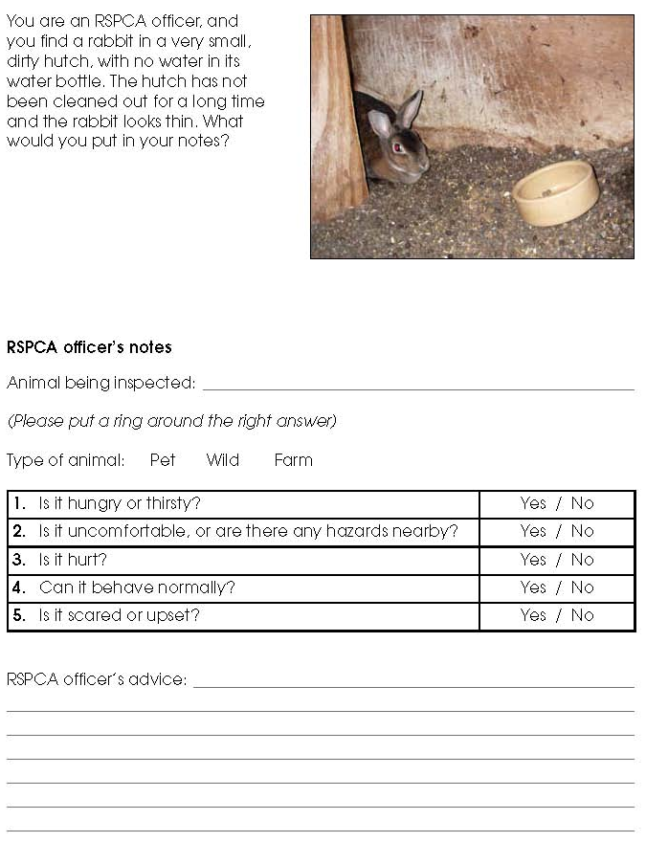

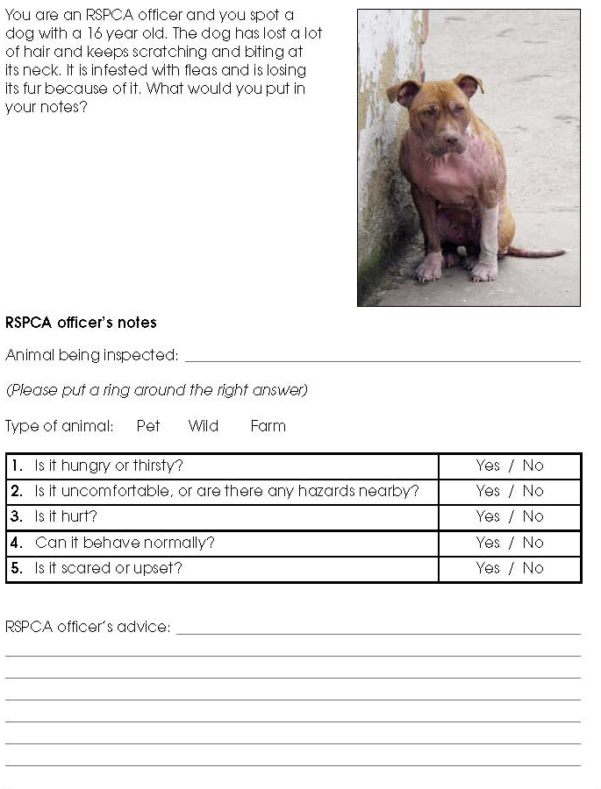
Activity sheet – What would you do? (2)

Activity sheet – What would an RSPCA officer say? (1)

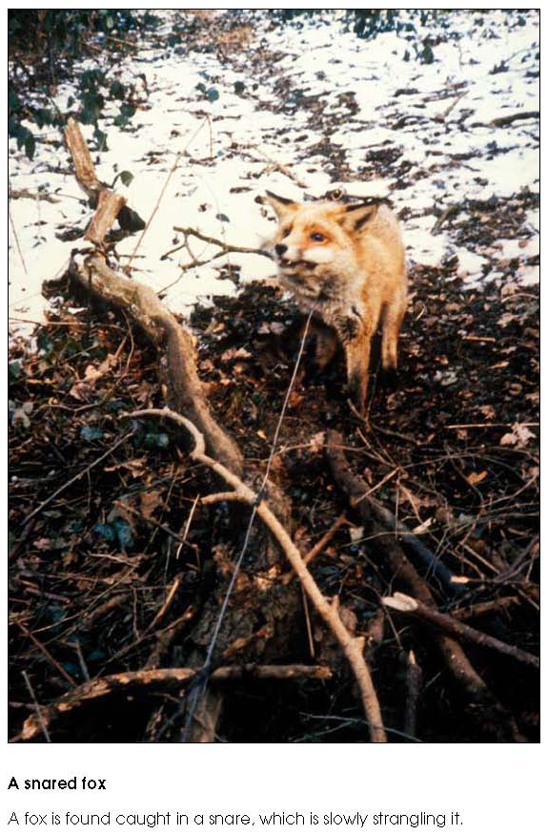

Activity sheet – What would an RSPCA officer say? (2)

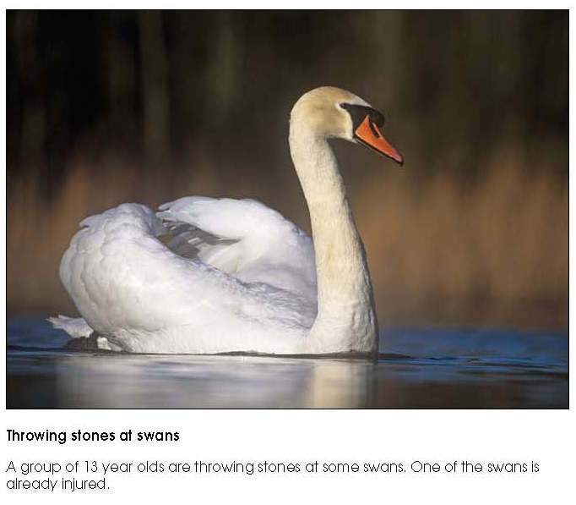

Fact sheet – RSPCA officers

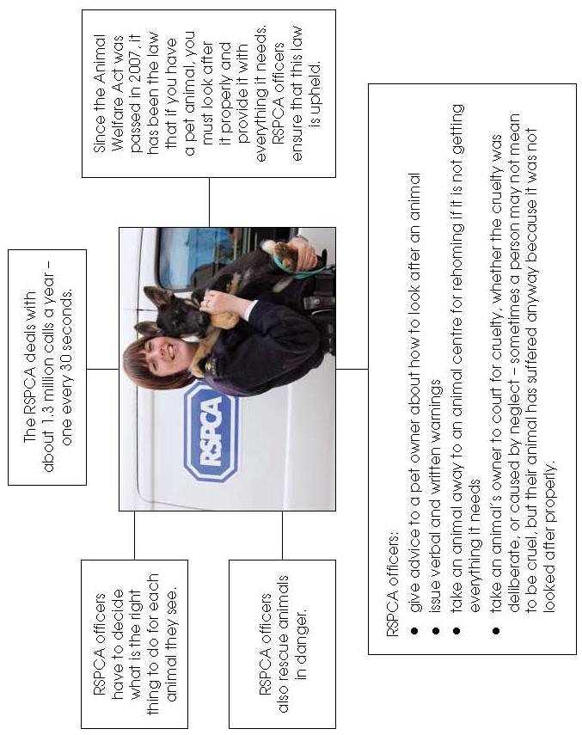

Facilitators’ notes – What would you do? (answers)

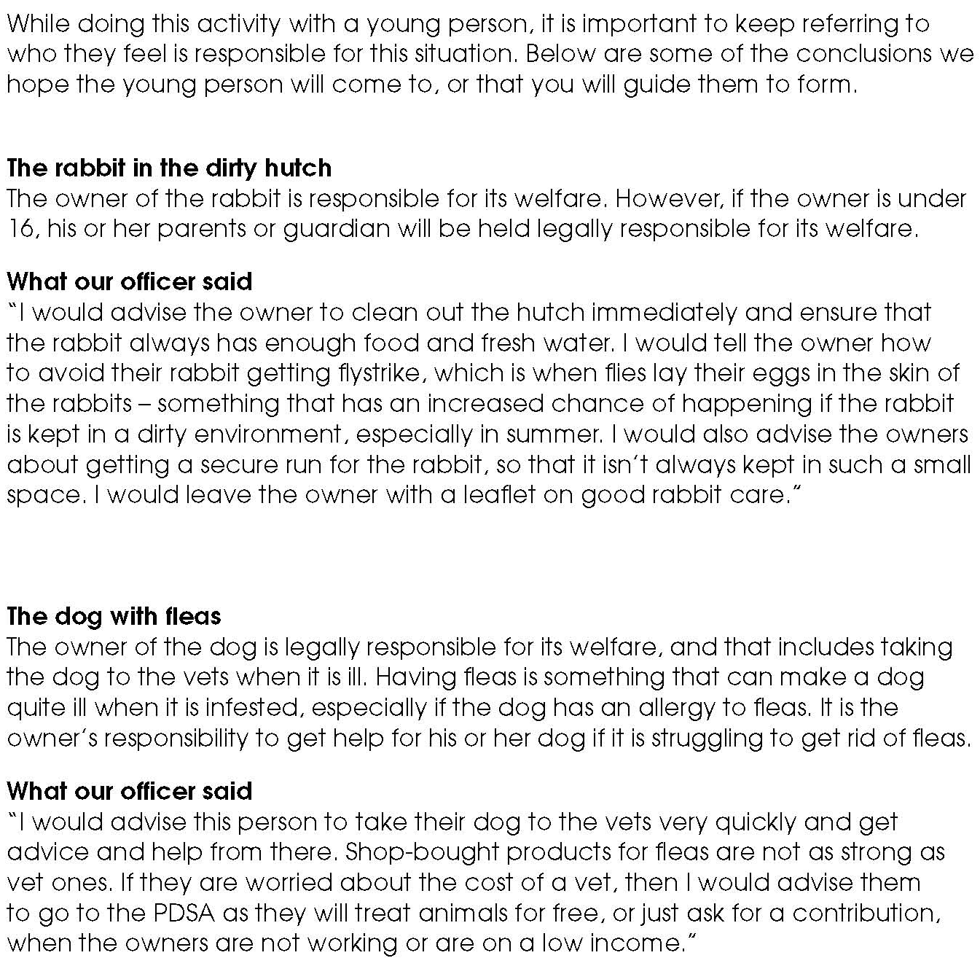

Facilitators’ notes – Cruelty to animals – how the law works

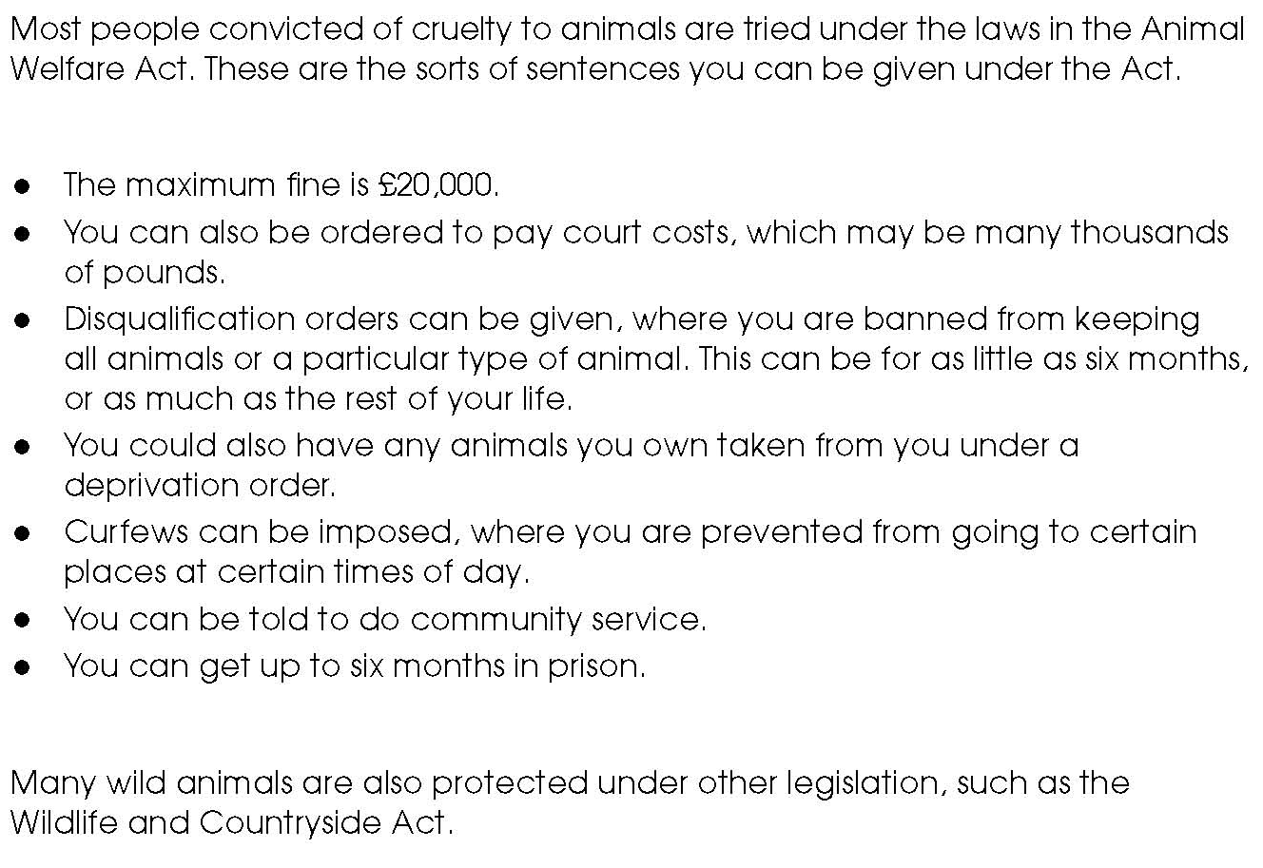

Facilitators’ notes – What would an RSPCA officer say? (answers)

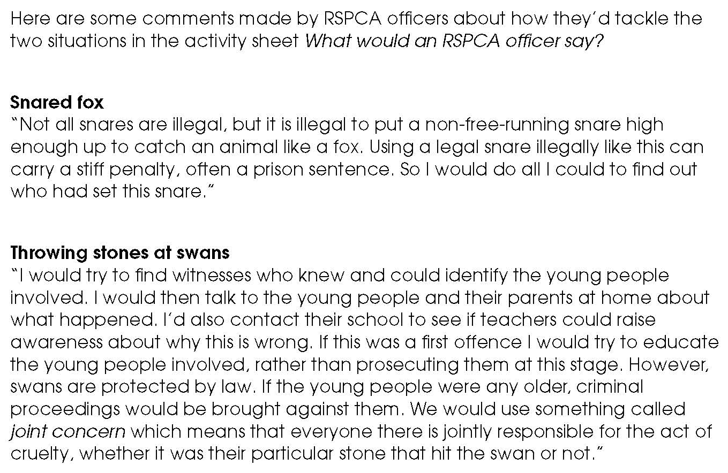

Facilitators’ notes – What would an RSPCA officer do?

